**Ellipsoid algorithm**

The Ellipsoid algorithm is the first polynomial-time algorithm discovered for linear programming. The Ellipsoid algorithm was proposed by the Russian mathematician Shor in 1977 for general convex optimization problems, and applied to linear programming by Khachyan in 1979. Contrary to the simplex algorithm, the ellipsoid algorithm is not very fast in practice; however, its theoretical polynomiality has important consequences for combinatorial optimization problems.

The problem being consider by the ellipsoid algorithm is:

Given a bounded convex set P $∈$ Rn find x $∈$ P

We will see that we can reduce linear programing to finding an x in P = {x $∈$ Rn : Cx≤ d}.

The ellipsoid algorithm works as follows. We start with a big ellipsoid E that is guar- anteed to contain P. We then check if the center of the ellipsoid is in P. If it is, we are done, we found a, it is explicitly given in the description of P) which is not satisfied by our center. One iteration of the ellipsoid algorithm is illustrated in next Figure. The ellipsoid algorithm is the following.

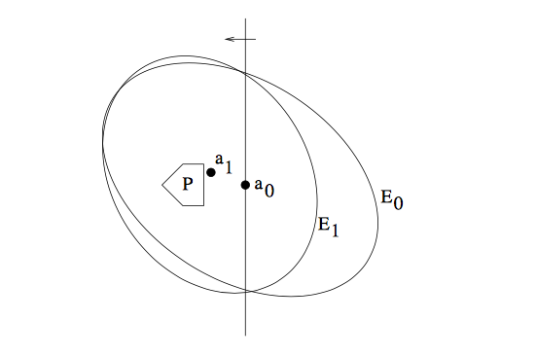

Algorithm:

1. Let E0 be an ellipsoid containing P
2. While center ak of Ek is not in P do:
   1. Let cTx <= cTak be such that {x : cTx <= cTak} P
   2. Let Ek+1 be the minimum volume ellipsoid containing Ek  {x : cTx <= cTak}
   3. k <- k+1

The ellipsoid algorithm has the important property that the ellipsoids contructed shrink in volume as the algorithm proceeds; this is stated precisely in the next lemma. This means that if the set P has positive volume, we will eventually find a point in P. We will need to deal with the case when P has no volume (i.e. P has just a single point), and also discuss when we can stop and be guaranteed that either we have a point in P or we know that P is empty.

**Definition of ellipsoid:**

Given a center a, and a positive definite matrix A, the ellipsoid E(a, A) is defined as {x $∈$ Rn (x-a)T A-1 (x-a) <=1 }

Also, we can use ellipsoid method when it is neccesary define : does the system of inequality Cx <= d belong any solution and find at least one of solution.

**Ellipsoid algorithm for linear programming**

If in the linear programming problem it was possible to construct a ball containing the desired solution (it describes in Ellipsoid method), then it can be solved be the ellipsoid method. To do this, first find some point u inside the ball, satisfying the constraints of the problem. Draw a hyperplane through it f(x) < f(u), where f – is our objective function, and then find point at the intersection of the original and new hyperplanes (starting from the current ellipsoid). Now, with the new found point, we do the same. Process converges to optimal solution with exponential speed (because value of ellipsoid decrease with exponential speed).